Soba Salad

 MARK BITTMAN

- Yield4 servings
TIMES CLASSIC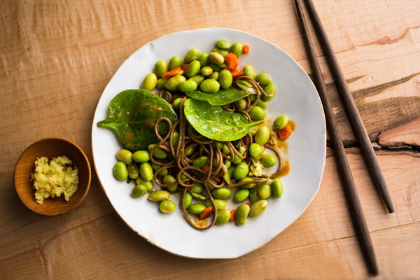
Andrew Scrivani for The New York Times
For most people, even experienced cooks, weeknight dinners are not so much a result of careful planning but of what’s on hand — and what can be accomplished fairly quickly. Noodles of all kinds are easy and beloved. But soba noodles, a Japanese staple, are special: they usually take no more than 3 to 4 minutes to cook and, because they’re made from buckwheat, have a slightly firm texture and a nutty flavor. Traditionally, soba are served hot and cold, making them a flexible partner for almost any fresh ingredients you have in the kitchen. In this case, they are paired with shelled frozen edamame, carrots and spinach and a light dressing.
Featured in: One Man’s Salad Is Another’s Noodles.
Vegetarian, Vegan, Asian
Cooked

114 ratings

INGREDIENTS
- Salt
- freshly ground pepper
- 3 to 4 ounces soba noodles
- 1 carrot, peeled and finely chopped
- 2 cups edamame (frozen are fine)
- 2 to 3 tablespoons soy sauce
- Juice of one lime
- 2 tablespoons white or light miso
- 1 tablespoon mirin or 1 teaspoon sugar, or to taste
- 1 10-ounce package fresh spinach, washed and trimmed
- ¼ cup chopped scallion
- 1 tablespoon freshly grated ginger

Nutritional Information

PREPARATION
- Bring a large pot of water to a boil and salt it. Drop in the noodles and carrot and cook until tender, 2 to 4 minutes; add the edamame for about 15 to 30 seconds just to warm, then drain everything in a colander. Set aside.
- In a large salad bowl, whisk together the soy sauce, lime juice, miso and mirin or sugar. Add spinach, noodles, carrot, edamame, scallion, and toss; then taste and season with salt and pepper as needed. Garnish with grated ginger at the table.

